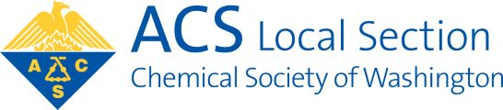
Chemical Society of Washington

WASHINGTON SECTION OF THE
AMERICAN CHEMICAL SOCIETY

Nomination Instructions

1. Use the nomination form below, a copy of the form, or submit the requested information using a sheet of paper and labeled “Nomination Form” by mail or electronically. Send completed form by e-mail to csw@acs.org - Attn: Chair, Nominations Committee. Nominations must be submitted with this form or they will not be accepted.

2. For each nomination, indicate the corresponding office, name of the nominee, and the nominee’s telephone number or email address, if known. IMPORTANT: If you have determined that the nominee is a CSW member and is willing to be a candidate, please indicate this next to the candidate’s name.

3. Please submit your form in time to arrive by August 15th.

Nominations are invited for the following offices/ positions (numbers of positions to be filled shown in parentheses). President-Elect (1); Secretary (1); Councilors, including Alternate Councilors (9); Managers (6). For Each Nominee: please indicate the office or position, the name of the nominee, whether the nominee is a CSW member and is willing to be a candidate, and, if known, the telephone number (including area code) and e-mail address of the nominee.

Office / Position: | President-Elect | Secretary |  | Councilor /  Alternate Councilor | Manager

Name of Nominee:
Title (Dr., Ms., Mr.) First Name Last Name

Willing to run (y)?

Phone
Enter format 123-456-7890

E-mail address

Return form to CSW
All nominations must use this form.
csw@acs.org

Chemical Society of Washington
ATTN: Chair, Nominations Committee
1155 16th Street, N.W., O-218
Washington, DC 20036

