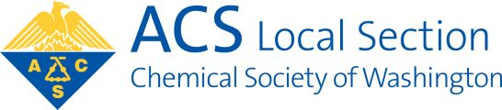
Chemical Society of Washington

WASHINGTON SECTION OF THE
AMERICAN CHEMICAL SOCIETY

Nomination Instructions

1. Use the nomination form below, a copy of the form, or submit the requested information using a sheet of paper and labeled “Nomination Form” by mail or electronically. Send completed form by e-mail to csw@acs.org - Attn: Chair, Nominations Committee. Nominations must be submitted with this form or they will not be accepted.

2. For each nomination, indicate the corresponding position, name of the nominee, and the nominee’s email address.

3. Please submit your form in time to arrive by August 15th.

Nominations are invited for the following offices/ positions (numbers of positions to be filled shown in parentheses). President-Elect (1); Treasurer (1); Councilors, including Alternate Councilors (5); Managers (6).

Nomination for: | President-Elect | Treasurer |  | Councilor /  Alternate Councilor | Manager

Name of Nominee:
First Name Last Name Preferred Name / Nickname (optional)

Is the nominee a CSW member? Yes No Unsure

Has the nominee confirmed a willingness to run? Yes No Unsure

E-mail address:

Phone (optional):
Enter format 123-456-7890

Return form to CSW
All nominations must use this form.
csw@acs.org

Chemical Society of Washington
ATTN: Chair, Nominations Committee
1155 16th Street, N.W., O-218
Washington, DC 20036

