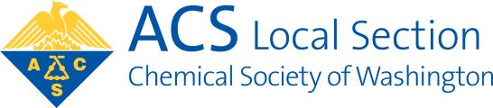
Chemical Society of Washington

WASHINGTON SECTION OF THE
AMERICAN CHEMICAL SOCIETY

Nomination Instructions
Nominations must be submitted with this form or they will not be accepted.

1. Fill out the nomination form below and e-mail to csw@acs.org with subject:
CSW Nomination

2. For each nomination, indicate the corresponding position, name of the nominee, and the nominee’s email address.

3. We request nominations be submitted to CSW before July 1, though members may continue to submit nominations up to August 15.

Nominations are invited for the following offices/ positions, please select 1 per nomination form:

Nomination for: | President-Elect | Treasurer |  | Councilor /  Alternate Councilor | Manager

Name of Nominee:
First Name Last Name Preferred Name / Nickname (optional)

Is the nominee a CSW member? Yes No Unsure

Has the nominee confirmed a willingness to run? Yes No Unsure

Nominee E-mail address:

Nominee Phone (optional):
Enter format 123-456-7890

Return form to CSW csw@acs.org with subject: CSW Nomination

